Abstract— Cloud Computing is the hottest trend in the IT World and each and every company is slowly but surely getting engrossed and migrating to this big thing. In this paper we have explained the basic concepts related to Cloud Computing and its types. Further we have explored private cloud in detail by providing Eucalyptus as an example. By exploring its architecture and functioning in detail, we observed a lack of interface for the management of private cloud and thus we have a made a cloud management platform that manages the cloud in the best possible manner even considering client’s experience at the same time. It also incorporates performance monitoring tool which provides with dynamic resource allocation based on our various proposed parameters.
Cloud Management Platform with Performance Monitoring

Index Terms—Cloud Computing, Private Cloud, Eucalyptus, Automation, Cloud Management Platform, Performance Monitoring, GUI and Associative Rule.

INTRODUCTION
Traditional dedicated servers ,also called as on-premise servers are the ones which are situated inside the standalone data center. They require power , cooling, networks , bandwidth and infinite amount of storage. In addition to above, it cannot work without a software stack and a team of experts required for starting , configuring and running the system .They are also responsible for product development, staging, testing and also for failures in various environments.On top of it any new version or update results in the destruction of the whole software stack. Because of all these factors, business applications deployed on this infrastructure are very expensive and thus the small business companies can’t just afford it. On the contrary cloud computing is much faster as it is just plug n play and the platform is ready. It requires no technical experts, no severs , no storage and no upgrades but just directly customizing applications which are on the shared data center based on the client’s needs. Since the burden of initial setup is eliminated the company is up and running in few days instead of hard long lasting months for its setup.

POWER OF CLOUD COMPUTING
National Institute of Standard and technology ( NIST) defines cloud computing as “a model for enabling convenient, on-demand network access to a shared pool of configurable computing resources (e.g., networks, servers, storage, applications, and services) that can be rapidly provisioned and released with minimal management effort or service provider interaction” (Mell & Grance, 2009, p. 1).The NIST definition of cloud computing includes five essential characteristics (on-demand self-service, broad network access, resource pooling, rapid elasticity, measured service), three service models (infrastructure, platform, software), and three deployment models (private, hybrid, public) .

Pillars of Cloud Computing

Orchestration
Orchestration describes the automated arrangement, coordination, and management of complex computer systems, middleware, and services.It is often discussed as having an inherent intelligence or even implicitly autonomic control, but those are largely aspirations or analogies rather than technical descriptions. In reality, orchestration is largely the effect of automation or systems deploying elements of control theory. Orchestration in this sense is about aligning the business request with the applications, data and infrastructure. It defines the policies and service levels through automated workflows, provisioning, and change management. This creates an application-aligned infrastructure that can be scaled up or down based on the needs of each application. Orchestration also provides centralized management of the resource pool, including billing, metering, and chargeback for consumption. For example, orchestration reduces the time and effort for deploying multiple instances of a single application. And as the requirement for more resources or a new application is triggered, automated tools perform tasks that before could only be done by multiple administrators operating on their individual pieces of the physical stack.

Virtualization

Virtualization is a method of running multiple independent virtual operating systems on a single physical computer. It is a way of maximizing physical resources to minimize the investment in hardware. Thus virtualization is a method of dividing a high processing server into small moderate servers, thus acting multiple physical machines with the help of a single terminal .

Multitenancy

Multitenancy refers to a principle in software architecture where a single instance of the software runs on a server, serving multiple client organizations (tenants). Multitenancy is contrasted with a multi-instance architecture where separate software instances (or hardware systems) are set up for different client organizations. With a multitenant architecture, a software application is designed to virtually partition its data and configuration, and each client organization works with a customized virtual application instance. Multitenancy is regarded as one of the essential attributes of Cloud Computing.

Advantages of Cloud Computing

-Low setup cost (pay for only what you use)

The billing is on hourly or monthly basis. You pay only for the resources your actually consume. This is unlike the traditional services where you pay a fixed amount even if you don’t use the resources, or don’t have enough clients to consume the preconfigured resources. In cloud computing, you pay less if you have a lower customer base and vice-versa.

-More Scalable

Cloud is elastic in nature, i.e., you can control the number of resources you use at any given point in time. Compare this with traditional hosting, where you rent a fixed number of resources for fixed amount of time. Using Cloud Computing you can easily configure your resources for unexpected spikes in traffic. Based on your computing requirements and configuration, your cloud service provider can respond quickly to scale up or down i.e. Auto Scaling. This is suitable for applications that undergo quite unpredictable spikes in traffic on an hourly, daily or weekly basis; they will now have the resources they need On-Demand!

-More Reliable

Most people seem to follow the idea that if you have a Dedicated Server in a datacentre and it fails someone will immediately run to it and fix it but it won’t be an instant fix, this is because someone’s actually got to fix the problem and this takes time. The difference with the Cloud is that its providers have many data centres located all over the world, so if any instance goes down, or even an entire datacentre goes down, you just start up a new instance somewhere else, the problem is solved in a matter of minutes.

-Regular Upgrading
Cloud Vendors regularly upgrade their software, so that the users don’t have to put any effort into installing and upgrading the applications. This enhances the user experience and thus its utility.

-Ubiquitous Access
A major advantage of cloud is that it can easily and quickly be accessed from anywhere with a web browser. This gives users a great facility even when they are at home or in another country. They can access real time synchronized applications from Laptops and Smart Phones.
GENERIC ARCHITECTURE
When talking about a cloud computing system, it's helpful to divide it into two sections: the front end and the back end. They connect to each other through a network, usually the Internet. The front end is the side the computer user, or client, sees. The back end is the "cloud" section of the system.
The front end includes the client's computer (or computer network) and the application required to access the cloud computing system. Not all cloud computing systems have the same user interface. Services like Web-based e-mail programs leverage existing Web browsers like Internet Explorer or Firefox. Other systems have unique applications that provide network access to clients.
On the back end of the system are the various computers, servers and data storage systems that create the "cloud" of computing services. In theory, a cloud computing system could include practically any computer program you can imagine, from data processing to video games. Usually, each application will have its own dedicated server.
A central server administers the system, monitoring traffic and client demands to ensure everything runs smoothly. It follows a set of rules called protocols and uses a special kind of software called middleware. Middleware allows networked computers to communicate with each other

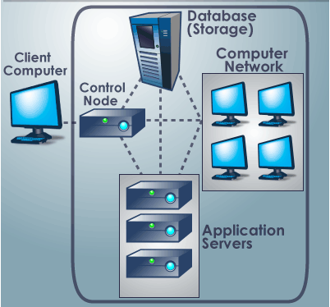
Fig.1 Cloud Computing Architecture

The above given figure 1 gives the general understanding of the organization of the different components of cloud computing.

TYPES OF CLOUD

What is a public cloud?
A public cloud is one based on the standard cloud computing model, in which a service provider makes resources, such as applications and storage, available to the general public over the Internet. Public cloud services may be free or offered on a pay-per-usage model.
Examples of public clouds include Amazon Elastic Compute Cloud (EC2), IBM's Blue Cloud, Sun Cloud, Google AppEngine and Windows Azure Services Platform.

What is a private cloud?
Private clouds take two forms: internal clouds and external private clouds. An internal cloud is inside your data center (on-premises), giving IT managers complete control over the available resources. A typical internal cloud relies on the security measures available within the cloud and within your data center. Ubuntu Enterprise Cloud(Eucalyptus) and Microsoft Azure are examples of packaged software for creating internal clouds.
External private clouds combine characteristics of internal clouds and public clouds. They are like public clouds because they are off-premises. But unlike public clouds, applications run on dedicated servers, and the cloud provider has built container walls around the external private cloud to make it more secure than public clouds. IT managers have more control over the resources in a private cloud than over resources in a public cloud. Amazon's Virtual Private Cloud is an example of an external private cloud.

Hybrid cloud
Hybrid cloud is a composition of two or more clouds (private or public) that remain unique entities but are bound together, offering the benefits of multiple deployment models. By utilizing "hybrid cloud" architecture, companies and individuals are able to obtain degrees of fault tolerance combined with locally immediate usability without dependency on internet connectivity. Hybrid Cloud architecture requires both on-premises resources and off-site (remote) server based cloud infrastructure.
As private cloud is built on the existing on-premise infrastructure, migrating from traditional server configuration to cloud computing architecture is not prohibited, thus it is very flexible. Since cloud computing architecture depends on the way it has been developed, it varies from developer to developer. Hence each developer can customize the cloud architecture according to its needs. Even as security is the prime factor for judgement, private cloud is more superior to public cloud as in this case the user doesn’t have to give the private information to its cloud service provider.Thus in this paper we have explored eucalyptus private cloud which is a software platform for on-premise (private) clouds. It is offered by Eucalyptus Systems, which provides IT organizations and technology businesses with this platform for on-premises private clouds.

Eucalyptus architecture
Eucalyptus was originally built as an open source cloud product and now supports enterprise-class private cloud as well as hybrid cloud computing. Eucalyptus uses existing infrastructure to create a scalable, secure web services layer that abstracts compute, network, security groups and storage to offer IaaS. It takes advantage of modern infrastructure virtualization software to create elastic pools that can be dynamically scaled up or down depending on application workloads. Eucalyptus web services are uniquely designed for hybrid clouds using the industry standard Amazon Web Services (AWS) API. The benefits are highly efficient scalability, increased trust and control for IT as a service

Components

Eucalyptus Overview

Eucalyptus was designed to be easy to install and as non-intrusive as possible. The software framework is modular, with industry-standard, language-agnostic communication. Eucalyptus provides a virtual network overlay that both isolates network traffic of different users and allows two or more clusters to appear to belong to the same Local Area Network (LAN). Also, Eucalyptus offers API compatability with Amazon’s EC2, S3, and IAM services. This offers you the capability of a hybrid cloud.

Eucalyptus Components

Eucalyptus is comprised of six components: Cloud Controller (CLC), Walrus, Cluster Controller (CC), Storage Controller (SC), Node Controller (NC) and an optional VMware Broker (Broker or VB). Other than the VMware Broker, each component is a stand-alone web service. This architecture allows Eucalyptus both to expose each web service as a well-defined, language-agnostic API, and to support existing web service standards for secure communication between
its components. A detailed description of each Eucalyptus component follows.

Cloud Controller
The Cloud Controller (CLC) is the entry-point into the cloud for administrators, developers, project managers, and end-users. The CLC queries other components for information about resources, makes high-level scheduling decisions, and makes requests to the Cluster Controllers (CCs). As the interface to the management platform, the CLC is responsible for exposing and managing the underlying virtualized resources (servers, network, and storage). You can access the CLC through command line tools that are compatible with Amazon’s Elastic Compute Cloud (EC2) and through a web-based Dashboard.

Walrus
Walrus allows users to store persistent data, organized as buckets and objects. You can use Walrus to create, delete, and list buckets, or to put, get, and delete objects, or to set access control policies. Walrus is interface compatible with Amazon’s Simple Storage Service (S3), providing a mechanism for storing and accessing virtual machine images and user data. Walrus can be accessed by end-users, whether the user is running a client from outside the cloud or from a
virtual machine instance running inside the cloud.

Cluster Controller
The Cluster Controller (CC) generally executes on a machine that has network connectivity to both the machines running the Node Controllers (NCs) and to the machine running the CLC. CCs gather information about a set of NCs and schedules virtual machine (VM) execution on specific NCs. The CC also manages the virtual machine networks. All NCs associated with a single CC must be in the same subnet.

Storage Controller
The Storage Controller (SC) provides functionality similar to the Amazon Elastic Block Store (Amazon EBS). The SC is capable of interfacing with various storage systems (NFS, iSCSI, SAN devices, etc.). Elastic block storage exports storage volumes that can be attached by a VM and mounted or accessed as a raw block device. EBS volumes persist past VM termination and are commonly used to store persistent data. An EBS volume cannot be shared between VMs and can only be accessed within the same availability zone in which the VM is running. Users can create snapshots from EBS volumes. Snapshots are stored in Walrus and made available across availability zones. Eucalyptus with SAN support lets you use your enterprise-grade SAN devices to host EBS storage within a Eucalyptus cloud.

Node Controller
The Node Controller (NC) executes on any machine that hosts VM instances. The NC controls VM activities, including the execution, inspection, and termination of VM instances. It also fetches and maintains a local cache of instance images, and it queries and controls the system software (host OS and the hypervisor) in response to queries and control requests
from the CC. The NC is also responsible for the management of the virtual network endpoint.

VMware Broker
VMware Broker (Broker or VB) is an optional Eucalyptus component, which is available if you are a Eucalyptus subscriber. VMware Broker enables Eucalyptus to deploy virtual machines (VMs) on VMware infrastructure elements. VMware Broker mediates all interactions between the CC and VMware hypervisors (ESX/ESXi) either directly or through VMware vCenter.

After understanding the basic functionalities of each component, we will now unearth the Eucalyptus architecture.
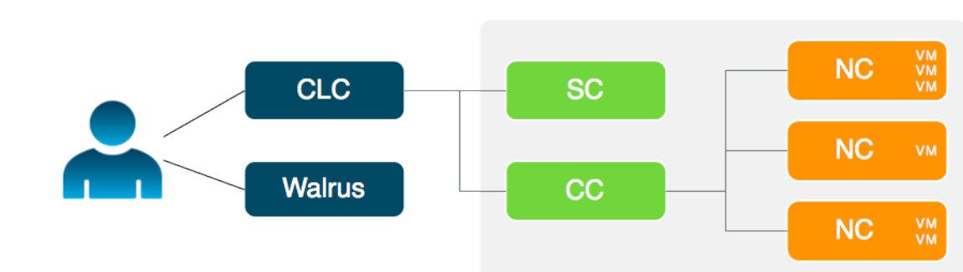
Fig 2.Eucalyptus Architecture

Working

The cloud components, Cloud Controller (CLC) and Walrus, communicate with cluster components, the Cluster Controllers (CCs) and Storage Controllers (SCs). The CCs and SCs, in turn, communicate with the Node Controllers (NCs). The networks between machines hosting these components must be able to allow TCP connections between them. However, if the CCs are on separate network interfaces (one for the network on which the cloud components are hosted and another for the network that NCs use) the CCs will act as software routers between these networks in some networking configurations. So each cluster can use an internal private network for its NCs and the CCs will route traffic from that
network to a network shared by the cloud components. Virtual machines (VMs) run on the machines that host NCs. You can use the CCs as software routers for traffic between clients outside Eucalyptus and VMs. Or the VMs can use the routing framework already in place without CC software routers. However, depending on the layer-2 isolation characteristics of your existing network, you might not be able to implement all of the security features supported by Eucalyptus.

But one of the major shortcoming of using Eucalyptus private Cloud is that it lacks an user interface for its management and deployment of instances. Because of this every client is fully dependent on the administrator to carry out most of the operations such as creating an instance, terminating an instance, creating Volume and taking Snapshots. In addition to this even the administrator has to run scripts to check and monitor the instances which take a lot of time.

Need for Automation
To realize the opportunities of the cloud, you need cloud management that gives you the extreme efficiency, speed, and control to navigate and seize these opportunities. To overcome these shortcomings we propose to make a Cloud Management Platform which will consist of an easily usable Graphical User Interface allowing the clients to operate independently. The User Interface will allow the client to start an instance, to terminate an instance, assign a volume to it and will make a snapshot of it. It will also provide additional features such as adding users, giving priorities to users and accordingly assigning key pairs to them. In short, this cloud management platform will be useful to both the client as well as the admin.
Our Cloud Management Platform provides a transparent "single pane of glass" view into your entire cloud infrastructure. The client can conveniently access his private cloud and resource pools from one Dashboard. Here the client can provision entire server deployments in minutes and then automate and govern them over their lifetimes. Everything is visible, organized, and controlled. And it works across various private clouds.
With our cloud management platform, managing 10 or 1,000 servers can be equally simple.
Our Cloud Management Platform bridges the gap between your applications and your cloud infrastructure. The MultiCloud feature provides a universal remote to conveniently access your private cloud resource pools from one Dashboard and API.. The Automation Engine feature gives you the power to provision, monitor, scale, and manage entire server deployments efficiently and reliably. Automaion is what makes the cloud's scalability and low cost possible. But if automation isn't done properly it will actually result in more work for IT staff and thus would hamper their growth.

Thus we have designed and developed a Graphical User Interface for managing the private cloud as shown in the figure given below.

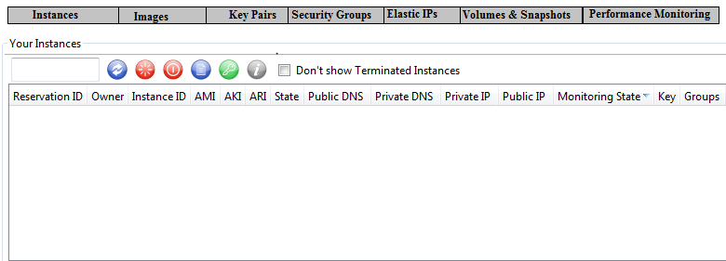
Fig 3.Graphical User Interface

The various options given in the figure are explained in detail in the follwing section.

1. Instances
Under this tab, the client would be able tocarry out the following functionalities:

a. Start an Instance
This will give the client a drop down list of the virtual machine images bundled with the private cloud.

b.Terminate an Instance
This will give the client an option to terminate or halt the selected instance\s.

c. Refresh an Instance
This will give the client an option to refresh the selected instance\s.

d. Reboot an Instance
This will give the client an option to restart the selected instance\s.

e. Console O/p
This will give the client the console o/p of the selected instances.

2. Images
Under this tab, the client can have a look of all the machine images bundled with the private cloud and select the image required for the client desired instance.

3.Key Pairs
This tab gives an option of creating a private key which is required by the client whenever he wants to start an instance. Private key is generated based on the security algorithm of the software platform and thus this component is very important for security.

4.Security Groups
Using this tab, the client can form a security group where he can add user identities which would be authorised to access his instance/s.

5.Elastic IPs
This tab gives the client the IP Address of the instances.

6.Volumes And Snapshots
Under this tab, the client gets an option of creating a volume(storage space) of his desired size(GB) and which he can assign to any instance of his choice. It also gives an option to the client of creating a snapshot of the volume at any given time and the vice versa is also true.

7.Performance Monitoring
This tab gives in-depth information of the resource utilization of the client’s instance/s. This tab will monitor the capability of components of cloud in delivering the expected services and this monitoring will be based on the factors explained in the next section.

V. Performance Monitoring
Since we have various types of IT Components in a cloud, the traditional performance management which focuses on specific components will not work for cloud. They are not well equipped to provide a more holistic view of the cloud environment. More than independent management of physical and virtual infrastructure elements ,focus should be on how they perform to deliver the Business Service to the User. Service Level Agreements (SLAs) are very important in a Cloud environment. Since the Customer pays for the services infrastructure he uses , customer needs to be assured of a level of service at any time. As the key feature of cloud computing is scalability and elasticity, the clients should not suffer from slow performances. Thus we need a fully functional, well-equipped system that can take care of each and every scenario and thus provide the client with the required resources at the right time for excellent performance. Thus in order to service these requests, in our GUI we have proposed the parameters which contributes to the performance monitoring and will also apply a associative rule data mining technique on these parameters to get the optimum result.

The various parameters are shown in Fig 4 which is given below.

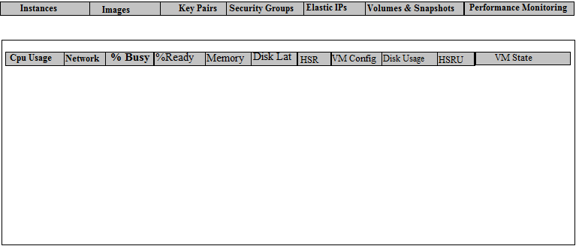
Fig 4.Performance Monitoring Parameters

The significance of various parameters are as follows

1.CPU Usage
CPU usage is the summation of percentages of the CPU time used by each process(out of 60 sec).

2.Network/bytes in/out
Average number of bytes per second sent/receive by the process in the last minute.

3.Percentage Buzy
Percentage Buzy is directly dependent on CPU Usage such that high CPU Usage means more buzy.

4.Percentage Ready
Percentage Ready is also directly dependent on CPU Usage such that low CPU Usage means more ready.

5.Physical Memory Used
This is the percentage of physical memory used by the processes.

6.Disk Latency
Disk Latency is the time required by the processes to complete their I/O operations.

7.Host System State(HSS)
Host System is a computer on a network, which provides services to users or other computers on that network. HSS consists of the different states such as idle, buzy, ready etc of the host system.

8.Virtual Machine Configuation
Virtual machine configuration is the arrangement of resources assigned to a virtual machine. The resources allocated to a virtual machine (VM) typically include allocated processors, memory, disks, network adapters and the user interface. Configuration refers to both the specific elements included and the way those elements are set up.

9.Disk Usage
Disk usage is the summation of percentages of the Disk bytes that are read and received by each pocess(out of 60 sec).

10.Host System Resource Usage(HSRU)
The host system resource usage tables contain information about the host system resource usage for all engine systems and the compute nodes they use to deploy parallel jobs.

11.Virtual Machine State
Virtual Machine State consists of the different states of the virual system.

To get the actual values of all the above parameters we will use Resource Monitor for Windows and top and his various different versions for all the Linux flavours.

VI CONCLUSION AND FUTURE WORK
As stated above, private cloud is a next big thing in IT World because of all the advantages and the flexibility it offers. Thus it generates the necessity for having a cloud management platform that can efficiently manage the cloud and even enhance the user experience since it shields the user from the complicated private cloud architecture and also from the performance monitoring . The above mentioned things have been incorporated in our GUI, thus making it an ideal cloud management platform. Regarding performance monitoring which is a great helping option to the client, we will make a database of all the proposed parameters and will check each of their values in each and every possible scenario to explore each and every possibility after installing the cloud in our private network. For extreme efficiency and accuracy, we would give these values of database to the associative rule data mining technique which would assess each of the cases and would give the most optimum result or solution in case of some problem. In case any scenario exceeds the threshold decided by the data mining technique it will suggest or throw a warning to the admin to take the required actions to solve it.

References
[1] Hamzeh Khazaei, Jelena Misic and Vojislav B. Misic,. Performance Analysis of Cloud Computing Centers Using M=G=m=m þ r Queuing Systems.

[2] Wendy Ellens, Miroslav Zivkovi´c, Jacob Akkerboom, Remco Litjens, Hans van den Berg. Performance of Cloud Computing Centers with Multiple Priority Classes

[3] Hamzeh Khazaei, Jelena Misic and Vojislav B. Misic. Performance Analysis of Cloud Centers under Burst Arrivals and Total Rejection Policy.

[4]http://www.infosys.com/engineering-services/features-opinions/Documents/cloud-performance-monitoring.pdf

[5] http://www.eucalyptus.com/docs/3.1/ig-3.1.0.pdf.

[6]http://www.eecs.berkeley.edu/Pubs/TechRpts/2009/EECS-2009-28.pdf

[7]http://www.rightscale.com

